**Docker Networking**

Docker takes care of the networking aspects so that the containers can communicate with other containers and also with the Docker Host. If you do an **ifconfig** on the Docker Host, you will see the Docker Ethernet adapter. This adapter is created when Docker is installed on the Docker Host.

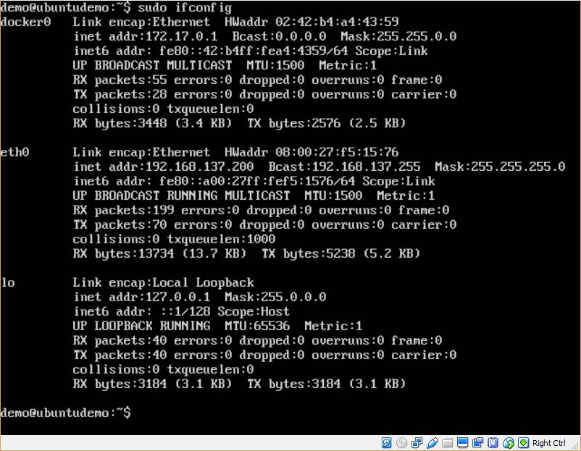

This is a bridge between the Docker Host and the Linux Host. Now let’s look at some commands associated with networking in Docker.

**Listing All Docker Networks**

This command can be used to list all the networks associated with Docker on the host.

**Syntax**

docker network ls

**Options**

None

**Return Value**

The command will output all the networks on the Docker Host.

**Example**

sudo docker network ls

**Output**

The output of the above command is shown below

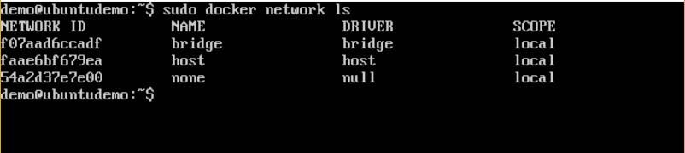

**Inspecting a Docker network**

If you want to see more details on the network associated with Docker, you can use the Docker **network inspect** command.

**Syntax**

docker network inspect networkname

**Options**

* **networkname** –This is the name of the network you need to inspect.

**Return Value**

The command will output all the details about the network.

**Example**

sudo docker network inspect bridge

**Output**

The output of the above command is shown below:

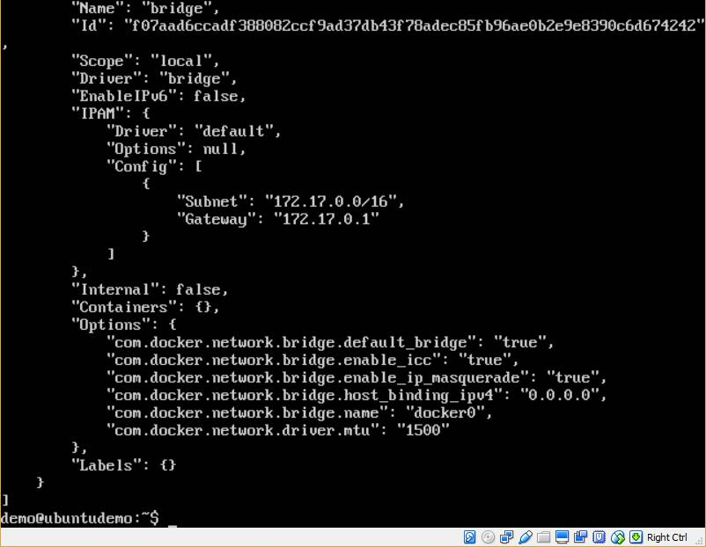

Now let’s run a container and see what happens when we inspect the network again. Let’s spin up an Ubuntu container with the following command:

sudo docker run –it ubuntu:latest /bin/bash

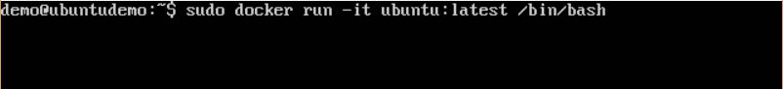

Now if we inspect our network name via the following command, you will now see that the container is attached to the bridge.

sudo docker network inspect bridge

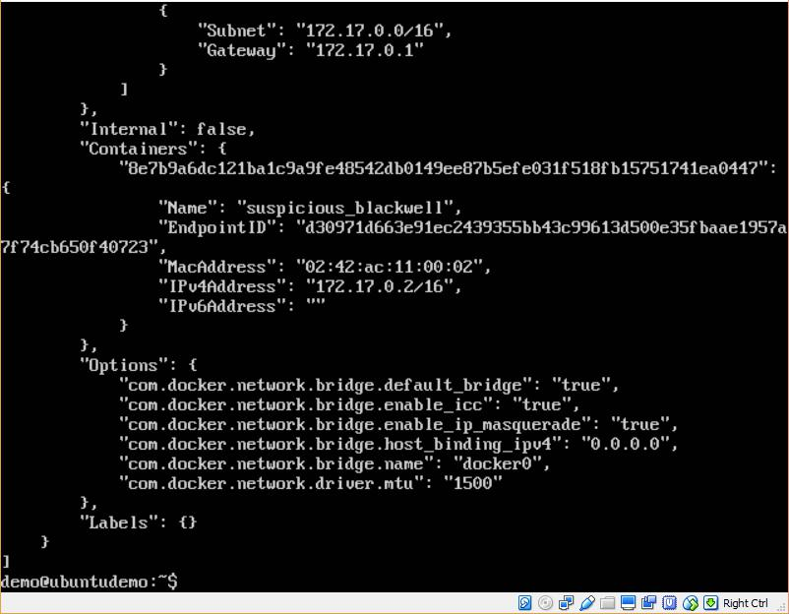

**Creating Your Own New Network**

One can create a network in Docker before launching containers. This can be done with the following command:

**Syntax**

docker network create –-driver drivername name

**Options**

* **drivername** –This is the name used for the network driver.
* **name** –This is the name given to the network.

**Return Value**

The command will output the long ID for the new network.

**Example**

sudo docker network create –-driver bridge new_nw

**Output**

The output of the above command is shown below:

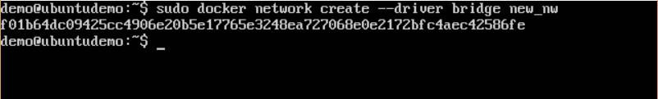

You can now attach the new network when launching the container. So let’s spin up an

Ubuntu container with the following command:

sudo docker run –it –network=new_nw ubuntu:latest /bin/bash

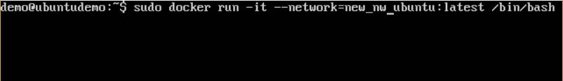

And now when you inspect the network via the following command, you will see the container attached to the network.

sudo docker network inspect new_nw

